Department of Information Technology
Academic Year: 2025-26 Name of Student: khushi anchalia
Semester: VI Student ID: 23104214
Class / Branch / Div: TE- IT A Roll No. 01
Subject: MAD & PWA Lab Date of Submission:25/3/26 Name of Instructor: Prof. Manjusha Kashilkar

Experiment No.:8
Aim: To Construct meta data for PWA in a Web app manifest file to enable “add to homescreen feature”

Prerequisites: HTML, JavaScript, JSON. Software: VS code, Browser.
Code:
Index.html

<html>
<head>
<base href="$FLUTTER_BASE_HREF">

<meta charset="UTF-8">
<meta content="IE=Edge" http-equiv="X-UA-Compatible">
<meta name="description" content="A new Flutter project.">

<!-- iOS meta tags & icons -->
<meta name="mobile-web-app-capable" content="yes">
<meta name="apple-mobile-web-app-status-bar-style" content="black">
<meta name="apple-mobile-web-app-title" content="hello_world">
<link rel="apple-touch-icon" href="icons/Icon-192.png">

<!-- Favicon -->
<link rel="icon" type="image/png" href="favicon.png"/>

<title>hello_world</title>
<link rel="manifest" href="manifest.json">
</head>
<body>
<script src="flutter_bootstrap.js" async></script>
</body>
</html>

Manifest.json
{
"name": "Sports E-Commerce", "short_name": "SportsApp", "start_url": ".",
"display": "standalone", "background_color": "#ffffff", "theme_color": "#000000", "icons": [
{
"src": "icons/Icon-192.png", "sizes": "192x192",
"type": "image/png"
}
]
}

Output:



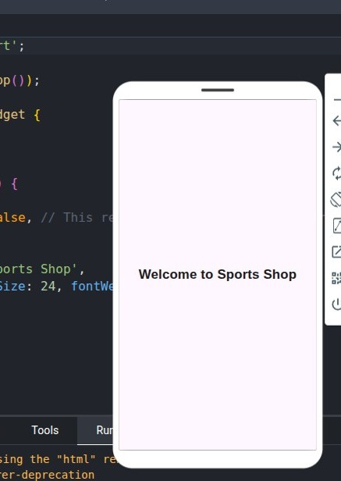

Conclusion: In this experiment we have designed PWA in a Web app manifest file to enable “add to homescreen feature”

